**2 GSM MODEM**

A GSM modem can be a dedicated modem device with a serial, USB or it can be mobile phone that provides GSM modem capabilities. The term GSM modem is used as a generic term to refer to any modem that supports one or more of the protocols in the GSM evolutionary family, including the 2.5G technologies GPRS and EDGE, as well as the 3G technologies WCDMA, UMTS, HSDPA and HSUPA.

A GSM modem exposes an interface that allows applications such as Now SMS to send and receive messages over the modem interface. The mobile operator charges for this message sending and receiving as if it was performed directly on a mobile phone. To perform these tasks, a GSM modem must support an “extended AT command set” for sending/receiving SMS messages, as defined in the [ETSI GSM 07.05](http://www.etsi.org) and [3GPP TS 27.005](http://www.3gpp.org/ftp/specs/html-info/27005.htm) specifications.

GSM modems can be a quick and efficient way to get started with SMS, because a special subscription to an SMS service provider is not required. In most parts of the world, GSM modems are a cost effective solution for receiving SMS messages, because the sender is paying for the message delivery. It should also be noted that not all phones support the modem interface for sending and receiving SMS messages.

The GSM/GPS Smart Modem is a multi-functional, ready to use, rugged unit that can be embedded or plugged into any application. The Smart Modem can be controlled and customized to various levels by using the standard AT commands. The modem is fully type-approved, it can speed up the operational time with full range of Voice, Data, Fax and Short Messages (Point to Point and Cell Broadcast) the logical level of the modem is not compatible with logical states of controller so need have logical conversion from modem to UART port of controller through MAX 232interface. The standard voltage range on RS-232 pins is _15V to +15V. This voltage range applies to all RS-232 signal pins. The total voltage swing during signal transmission can be as large as 30V. In many cases, RS-232 ports will operate with as low as _5V to+5V.

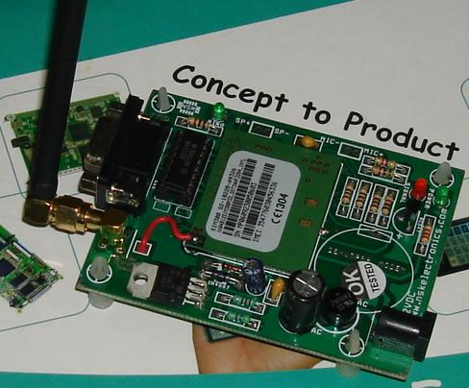

**Figure 4.4.2 GSM MODEM**

* **Introduction -** The hardware interface of the SIMCOM SIM300 module that connects to the specific application and the air interface. As SIM300 can be integrated with a wide range of applications, all functional components of SIM300 are described in great detail.
* **Product concept -** Designed for global market, SIM300 is a Tri-band GSM/GPRS engine that works on frequencies EGSM 900 MHz, DCS 1800 MHz and PCS 1900 MHz SIM300 features GPRS multi-slot class 10/ class 8 (optional) and supports the GPRS coding schemes CS-1, CS- 2, CS-3 and CS-4.
* **SIM card interface -** You can use AT Command to get information in SIM card. The SIM interface supports the functionality of the GSM Phase 1 specification and also supports the functionality of the new GSM Phase 2+ specification for FAST 64 kbps SIM (intended for use with a SIM application Tool-kit).Both 1.8V and 3.0V SIM Cards are supported. The SIM interface is powered from an internal regulator in the module having nominal voltage 2.8V.All pins reset as outputs driving low. Logic levels are as described in table.